*KNOWLEDGE & TECHNOLOGY*

# **Bangladesh Army University of Engineering & Technology**

**

Department of Computer Science and Engineering

A project report on

**A Car Trading Portal Using Django Web Framework**

A project is submitted in partial fulfillment for the requirements of the degree of Bachelor of Science in Computer Science and Engineering.

|  |
| --- |
| **Submitted by** |
| Golam Rabbi Hasan |
| ID No.: 18204042 |
| Ishaat Rahman Dipu |
| ID No.: 18204048 |
| Abdulah Al Mamun |
| ID No.: 18204050 |
| Kazi Sad Al Sakib |
| ID No.: 18104040  Sabbir Ahmed Preom  ID No.: 17204080 |
| **Supervised by** |
| Md. Omar Faruq |
| Lecturer, Department of CSE, BAUET |
| Md. Nazmus Salehin |
| Lecturer, Department of CSE, BAUET |
| Mst. Irin Sultana |
| Lecturer, Department of CSE, BAUET |

Department of Computer Science and Engineering

Bangladesh Army University of Engineering & Technology

April, 2022

*KNOWLEDGE & TECHNOLOGY*

# **Bangladesh Army University of Engineering & Technology**

**Department of Computer Science and Engineering**



**CERTIFICATE**

This is to certify that the project entitled “**A Car Trading Portal Using Django Web Framework” by “Golam Rabbi Hasan”, ID No.: 18204042, “Ishaat Rahman Dipu”, ID No.: 18204048, “Abdullah Al Mamun”, ID No.: 18204050, “Kazi Sad Al Sakib”, ID No.: 18104040, “Sabbir Ahmed Preom”, ID No.: 17204080,** has been accepted as satisfactory in partial fulfillment of the requirement for the degree of Bachelor of Science in Computer Science and Engineering on **April, 2022.**

Signature of Supervisor

**……………………..**

(Md. Omar Faruq, Lecturer)

**…………………….**

(Md. Nazmus Salehin, Lecturer)

**……………………..**

(Mst. Irin Sultana, Lecturer)

Department of Computer Science and Engineering

Bangladesh Army University of Engineering &Technology

*KNOWLEDGE & TECHNOLOGY*

# **Bangladesh Army University of Engineering & Technology**

**Department of Computer Science and Engineering**



**DECLARATION**

We hereby declare that project titled **“A Car Trading Portal Using Django Web Framework”** is a debonair Project. We also ensure that it does not previously submit or published elsewhere for the award of any degree or diploma.

The work has been accepted for the degree of Bachelor of Science in Computer Science and Engineering at Bangladesh Army University of Engineering & Technology (BAUET).

**Author(s)**

…………………………..

**(Golam Rabbi Hasan)**

…………………………..

**(Ishaat Rahman Dipu)**

…………………………..

**(Abdullah Al Mamun)**

…………………………..

**(Kazi Sad Al Sakib)**

…………………………..

**(Sabbir Ahmed Preom)**

**ACKNOWLEDGEMENT**

It is indeed with a great pleasure and immense sense of gratitude that we acknowledge the help of these individuals. We are highly indebted to our Supervisors **Md. Omar Faruq**, Lecturer Dept. Of CSE, **Md. Nazmus Salehin**, Lecturer, Dept. Of CSE, **Mst. Irin Sultana**, Lecturer Dept. Of CSE, for their guidance and constant supervision as well as for providing necessary information regarding the project.

Finally, we express our heart-full thanks to all of our friends who helped us in successful completion of this project.

Golam Rabbi Hasan

ID No.: 18204042

Ishaat Rahman Dipu

ID No.: 18204048

Abdulah Al Mamun

ID No.: 18204050

Kazi Sad Al Sakib

ID No.: 18104040

Sabbir Ahmed Preom

ID No.: 17204080

**ABSTRACT**

A used car, a pre-owned vehicle, or a second-hand car, is a vehicle that has previously had one or more retail owners. Used cars are sold through a variety of outlets, including franchise and independent car dealers, rental car companies, leasing offices, auctions, and private party sales. Some car retailers offer "no-haggle prices," "certified" used cars, and extended service plans or warranties. The individual who wants to use a car must first contact the car company for the desire vehicle. This can be done online. At this point, this person has to supply some information such as; dates and type of car. After these details are worked out, the individual renting the car must present a valid Identification Card. Most companies throughout the industry make a profit based of the type of cars that are used. The used cars are categorized into economy, compact, compact premium, premium and luxury. And customers are free to choose any car of their choice based on their purse and availability of such car at the time of reservation.

Bangladesh used car market with every passing day; the popularity of Japanese vehicles is increasing. They are famous for their reliability, comfort and durability. There is no doubt that Japanese are more devoted towards their work, hence the end result are always a vehicle that one feels proud to drive. Almost every country in the world import used vehicles from Japan. Like other countries, Bangladesh, a low-lying riverside country located in South Asia import large of used vehicles from Japan. Bangladesh is an important place for exportation of Japanese used vehicles

The economy of the country is growing progressively at around 6% over the last decade and in coming years it is expected to reach around 7-8%. The country is a developing economy. Also there are fast growing middle class people in the country. The sales of used cars has increased rapidly in Bangladesh in the recent years as more and more middle class people are buying cars. With the advancement in technology, and presence of many portal sites it has become easy for importers to purchase a vehicle. Buyers go online and compare the prices of various models all at a time, instead of visiting showrooms.

|  |  |  |
| --- | --- | --- |
| **List of contents** | | |
| **Chapter** | **Title** | **Page No.** |
|  | Certificate | ii |
|  | Declaration | iii |
|  | Acknowledgment | iv |
|  | Abstract | v |
|  | List of contents | vi |
|  | List of figures | viii |
|  |  |  |
| **1** | **INTRODUCTION** | **1-2** |
|  | 1.1 Introduction | 1 |
|  | 1.2 Background Study | 2 |
|  | 1.3 Statement of the problem | 2 |
|  | 1.3.1 General Problem | 2 |
|  | 1.4 Objectives | 2 |
|  | 1.4.1 Overall objectives | 2 |
|  | 1.4.2 Specific objectives | 2 |
|  | 1.5 Conclusion | 2 |
|  |  |  |
| **2** | **PLANNING** | **3-4** |
|  | 2.1 Introduction | **3** |
|  | 2.2 Method Used in Developing the Software Product | **3** |
|  | 2.3 Conclusion | **4** |
| **3** | **ANALYSIS** | **5-9** |
|  | 3.1 Introduction | **5** |
|  | 3.2 System Analysis | **5** |
|  | 3.3 Feasibility Study | **5** |
|  | 3.3.1 Technical Performance | **6** |
|  | 3.3.2 Time Occurrence | **6** |
|  | 3.3.3 Possible Performance | **6** |
|  | 3.3.4 Occupation Implementation | **6** |
|  | 3.3.5 Economic viability | **6** |
|  | 3.4 Requirements Analysis and Specification | **7** |
|  | 3.4.1 Requirements Gathering | **7** |
|  | 3.4.2. Data Collection Methods | **7** |
|  | 3.5 Requirements | **8** |
|  | 3.5.1 Functional requirements | **8** |
|  | 3.5.2 Non-Functional Requirements | **8** |
|  | 3.6 Conclusion | **9** |
| **4** | **DESIGN** | **10-13** |
|  | 4.1 Introduction | **10** |
|  | 4.2 Methodology | **10** |
|  | 4.3 Flow Chart | **11** |
|  | 4.4 Use Case Diagram | **12** |
|  | 4.5 Class Diagram | **13** |
|  | 4.6 Conclusion | **13** |
| **5** | **IMPLEMENTATION** | **14-22** |
|  | 5.1 Introduction | **15** |
|  | 5.2 Requirements | **15** |
|  | 5.3 Implementation Tools | **15** |
|  | 5.3.1 What is PostgreSQL | **16** |
|  | 5.3.2 What is Django? | **16** |
|  | 5.3.3 What does Django code look like? | **17** |
|  | 5.3.4 Database tables | **18** |
|  | 5.3.5 Login Module & Other Modules | **19** |
|  | 5.4 Conclusion | **22** |
|  |  |  |
| **6** | **TESTING AND INTEGRATION** | **23-24** |
|  | 6.1 Introduction | **23** |
|  | 6.2 Types of testing | **23** |
|  | 6.3 Conclusion | **24** |
|  |  |  |
| **7** | **MAINTENANCE** | **25-26** |
|  | 7.1 Introduction | **25** |
|  | 7.2 What Is Website Maintenance? | **25** |
|  | 7.3 Methods of Maintenance | **25** |
|  | 7.4 Conclusion | **26** |
| **8** | **CONCLUSION** | **27-28** |
|  | 8.1 Introduction | **27** |
|  | 8.2 Future Work | **27** |
|  | 8.3 Features | **27** |
|  | 8.4 Conclusion | **28** |
|  |  |  |
|  | **REFERENCES** | **29** |
|  |  |  |

|  |  |  |
| --- | --- | --- |
|  | **List of figures** |  |
| **Figure No.** | **Title** | **Page No.** |
| 2.1 | RAD Design | 4 |
| 4.1 | Flow chart of Car zone Web Portal | 11 |
| 4.2 | Use Case Diagram of Car zone Web Portal | 12 |
| 4.3 | Class Diagram of Car zone Web Portal | 13 |
| 5.1 | How Django Web Framework works | 17 |
| 5.2 | Database | 18 |
| 5.3 | Columns of auth_user Table. | 19 |
| 5.4 | Admin login | 19 |
| 5.5 | Site Administration | 20 |
| 5.6 | Cars Panel | 20 |
| 5.7 | User details in admin panel | 20 |
| 5.8 | Homepage of Car Zone Web Portal | 21 |
| 5.9 | Car Inventory Page of Car Zone Web Portal | 21 |
| 5.10 | Services Page of Car Zone Web Portal | 21 |
| 5.11 | Login Page of Car Zone Web Portal | 22 |
| 5.12 | Register Page of Car Zone Web Portal | 22 |

**Chapter 1**

**Introduction**

* 1. **Introduction**

A used car is the second-hand vehicle that is available for resale. Various outlets such as franchise and independent car dealers, rental car companies, auctions, private party sales, and leasing offices sell used cars. There is a lower rate of car ownership among millennial owing to high cost of vehicles and maintenance cost of personal car. In addition, millennial are inclined toward cutting costs on cars, and thus majorly opt for used cars to travel. In addition, a lot of people are not able to buy new cars due to high cost, which boosts the sales of the used cars in the market. This also makes way for different investments by industry participants to establish their dealership network in the market.

Factors such as high cost of new vehicles, concerns regarding affordability, rise in demand for off-lease cars & subscription service by the franchise, leasing offices, and car dealers are observed to boost the growth of the used cars market. However, unorganized sales of used cars and lack of regularization hamper the growth of the global market. Moreover, advent of e-commerce & online technologies, steady increase in organized/semi-organized sales in emerging countries, rise in electric vehicle business across the globe, and demand for car sharing services are expected to offer lucrative opportunities for the growth of the used cars market.

**1.2 Background Study**

The main aim of this project is to create a web application that is helpful while selling cars.

It is difficult to maintain the car information individually and to supply for the customers who are eager to buy them. Customer has to face difficulty in order to know the information of car like manufacturing year, car model and other valuable information in a single domain. Our main idea is to develop a system where we can have all the required information for the user in order to effectively interest him in the process of buying a car.

We made website for a car business owner who wants to list his cars on his website and allow the user to come to his site and browse through all of his latest cars and featured cars, search and filter the cars by model or price, and make some inquiries about his cars that are out for the sale. This Web Application can maintain car details like year of manufacturing, price and model etc. We can also view all the car details which are kept for sale effectively and we can search for our desired car. With this Customer can get the information quickly like car details which have been entered clearly.

**1.3 Statement of the problem**

1.3.1 General Problem

Getting a used car helps people get around despite the fact they do not have access to their own personal vehicle or don't own a vehicle at all. The individual who needs a car must contact a car company and contract out for a vehicle.

**1.4 Objectives**

A project objective is a statement that describes the “what” of your project. The tangible and measurable “what”. The “what” that’s achievable, realistic, and can be completed within the time allowed. These statements ladder up to the goals of the project, providing stepping stones to project success.

1.4.1 Overall Objectives

As the students of Computer Science and Engineering, we are motivated To produce a web-based system that allow customer to register and reserve car online and for the company to effectively manage their used car business.

1.4.2 Specific Objectives

* Financially our app is not so costly
* Quality of this web app is good then existing other management apps.
* There is a huge business opportunity of this app in future. Not only Admin but also car dealer of other company can use our application.

**1.5 Conclusion**

Web Application developed for a car company has been designed to achieve maximum efficiency and reduce the time taken to handle the selling activity. The system uses Django and Postrage as a backend for the database. It will considerably reduce data entry, time and provide readily calculated reports. Small car Dealership Company can use this accessible web application on their company. Purchasing software eliminates the expense of hiring employee or car agent.

**Chapter 2**

**Planning**

**2.1 Introduction**

A project plan is a formal, approved document used to guide both project execution and project control. The primary uses of the project plan are to document planning assumptions and decisions, facilitate communication among project stakeholders, and document approved scope, cost, and schedule baselines. A project plan may be summarized or detailed.

The objective of a project plan is to define the approach to be used by the project team to deliver the intended project management scope of the project.

**2.2 Method Used in Developing the Software Product**

Rapid Application Development (RAD) is web development methodology that uses minimal planning in favour of rapid prototyping. The “planning” of application developed using RAD is interleaved with writing the software itself. The lack of extensive re-planning generally allows software to be written much faster, and makes it easier to change requirements.

2.2.1 Four phases of Rapid Application Development (RAD)

* Requirements Planning Phase - combines elements of the system planning and systems analysis phases of the System Development Life Cycle (SDLC). User, managers, and IT staffs members discuss and agree on business needs, project scopes, constraints, and system requirements. It ends when the team agrees on the key issues and obtains management authorization to continue.
* User Design Phase - during this phase, user interacts with system analysis develop models and prototypes that represent all system processes, inputs, and output. The RAD groups or subgroups typically use a combination of Joint Application Development (JAD) techniques and CASE tools to translate user’s needs into working models. User Design is continuous interactive process that allows users to understand, modify, and eventually approve working model of the system that meets their needs.
* Construction Phase - focuses on program and application development task similar to the SDLC. In RAD, however, users continue to participate and can still suggest changes or improvements as actual screens or reports are developed. Its tasks are programming and application development, coding, unit integration and system testing.
* Cutover Phase - resembles the final tasks in the SDLC implementation phases, including data conversion, testing, changeover to the new system, and user training. Compared with traditional methods, the entire process is compressed. As a result, the new system is built, delivered, and placed in operation much sooner. Its task is data conversion, full-scale testing, system changeover, user training.

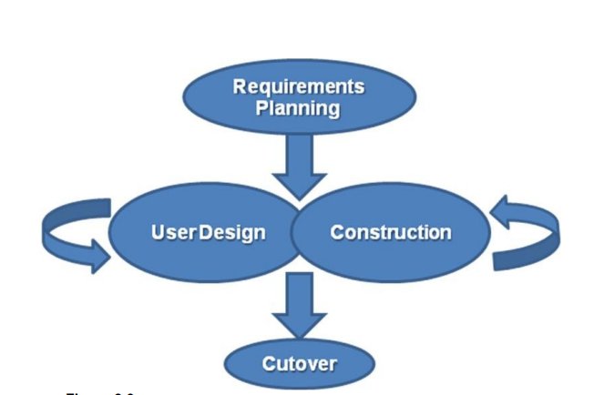

Figure 2.1: RAD Design

**2.2 Conclusion**

The planning process of any organization is essential to the overall success of the company. All levels of planning must do their part to incorporate situational analysis, alternative goals and plans, goals and plan evaluation, goal and plan selection, implementation, and monitoring.

Without proper planning, website development is not so easy and does not happen overnight. The whole process of web development is time-consuming and the result of long hours of commitment without scenes by business analysts, designers, developers, and testers.

**Chapter 3**

**Analysis**

**3.1 Introduction**

In current competitive scenario every car buy & sell business establishment needs quality process to increase their efficiency as well as improve their productivity. It is of vital importance that manual, time consuming and monotonous operations are automated so as to streamline the working of an organization.

It is keeping in mind this business philosophy that we propose an employee payroll system. In order to start gathering requirements, first it is necessary to identify each group affected by this project and understand everyone’s needs. With that information in hand, an initial list of the desired functional and non-functional requirements can be put into the Product Backlog in the form user stories. Every sprint these requirements may change, reason why in this section are described only the final requirements that are part of the current Product Backlog of the project. Non-functional properties, how usable, convenient, inviting and secure it is, may be the difference between an accepted, well-liked product, and an unused one.

**3.2 System Analysis**

An analysis is an important part of any project or any application, the analysis is not done correctly and the Whole project goes wrong. It also provides an appropriate project plan for the project. Analysis The work is divided into 3 sections:

* Identifying the Problem.
* Feasibility study.
* Needs Analysis.

**3.3 Feasibility Study**

The system feasibility study is a very important phase during system construction. A feasibility study is an evaluation of a program proposal in terms of its impact on organizational performance, ability to meet user needs and effective use of resources. The feasibility study determines whether the system is well developed or not. There are five possible types as mentioned below:

1. Technical Performance

2. Possibility of Timeline

3. Possibility of operation

4. Implementation of probability

5. Economic viability

3.3.1 Technical Performance

The feasibility of technology goes hand in hand with determining whether it is technically possible to develop software. Considering those tools, they will be needed to improve the project. Tools, available, and tools, will be required, are considered. Considering all the above points and features the costs incurred in developing this project from a technical point of view will not be very high. Therefore, the company and I can develop this program.

3.3.2 Time Occurrence

The probability of time depends on whether there is sufficient time to complete it project

Estimated parameters:

* Project schedule.
* Timeframe for completion of the project.
* Reporting time

Because of all of the above factors, it has been determined that the allotted time of 3 months is sufficient to complete the task.

3.3.3 Possible Performance

Operational feasibility depends on whether users know where to work and enough resources are available or not.

People with basic computer knowledge will be able to use our system effectively and easily, as the system can have an intuitive GUI. So, understanding the operation of the system and using it can be easy in the decision manufacturer's opinion.

All the necessary resources for the implementation and implementation of the program are already in the office.

3.3.4 Occupation Implementation

A possible implementation is about the infrastructure needed to improve the system. Considering all the points below, it is possible to improve the system.

Things to consider:

* All necessary infrastructure resources such as PCs, books, work manuals are provided.
* Appropriate guidance is provided.
* All required data and files are provided.

3.3.5 Economic viability

Economic Performance is about the total cost incurred in the system. Need for the software system software proposed by Django and PostgreSQL for performance and background improvements as well as HTML, CSS, JS for front-end UI.

**3.4 Requirements Analysis and Specification**

A complete understanding of the need for software is essential to the success of a web development effort. No matter how well-designed or well-coded it is, a poorly executed and straightforward system will disappoint the user and bring woe to the developers. The task of analyzing a requirement is the process of discovery, refinement, modification, and clarification. The scope of the software, developed by a system engineer and refined during project planning, is refined in detail. Required data models, information flow and control, and operational behavior are created. Currently, those who want to buy shoes and any kind of clothing should go to the store and buy this which is very annoying for customers so we download this site online. This website should be developed to simplify the procurement process and transparency and flexibility in performing each task.

3.4.1 Requirements Gathering

Also known as data collection. Data collection an important aspect of any type of research. Incorrect data collection can affect research results and ultimately lead to invalid results. The methods used to collect project needs include a qualitative review of existing.

3.4.2. Data Collection Methods

The study used several strategies such as an online survey and questionnaire. Advanced data collection methods play an important role in impact analysis by providing useful information to understand the processes behind the intended outcomes and to assess changes in people's perceptions of their well-being. In addition, quality methods can be used to improve the quality of survey-based quantitative testing by helping to produce a test concept, strengthen the structure of research questions, and supplement or clarify the findings of volume tests.

These methods are characterized by the following characteristics:

* They are usually less open and have less structured protocols.
* They rely heavily on negotiations; respondents may be interviewed several times to follow up on a particular issue, clarify concepts or check data reliability.
* They use triangulation to increase the reliability of their findings.

In general, their findings may not apply to any particular population, rather each study presents a single piece of evidence that can be used to find common patterns between different subjects of the same subject. Existing written and visual material was evaluated to obtain important data and information about system development. Information about appointment managers, patient management was collected. During the data collection, the investigation found how the current system works, not only that but also tried to find out what the problems are facing and how they can be better solved. Needs analysis and clarification of needs may seem like an easy task, but the appearance is deceptive. The content of the communication is very high, there are many chances of or misinformation. Uncertainty is possible. The problem facing a software engineer can be better understood by repeating an anonymous customer statement: "I know I believe you understand what you are saying, but I'm not sure you realize that what you heard was not what I meant."

**3.5 Requirements**

The requirements from the proposal system are divided into practical and non-practical and nonoperational requirements

3.5.1 Functional requirements

Functional requirements are those requirements that are used to illustrate the internal working nature of the system, the description of the system, and explanation of each subsystem. It consists of what task the system should perform, the processes involved, which data should the system holds and the interfaces with the user.

The functional requirements identified are:

* Customer’s registration: The system should allow new users to register online and generate membership card.
* Online reservation of cars: Customers should be able to use the system to make booking and online reservation.
* Automatic update to database once reservation is made or new customer registered: Whenever there’s new reservation or new registration, the system should be able update the database without any additional efforts from the admin.
* Feedbacks to customers: It should provide means for customers to leave feedback.

3.5.2 Non-Functional Requirements

It describes aspects of the system that are concerned with how the system provides the functional requirements. They are: -

* Security: The subsystem should provide a high level of security and integrity of the data held by the system, only authorized personnel of the company can gain access to the company’s secured page on the system; and only users with valid password and username can login to view user’s page.
* Performance and Response time: The system should have high performance rate when executing user’s input and should be able to provide feedback or response within a short time span usually 50 seconds for highly complicated task and 20 to 25 seconds for less complicated task.
* Error handling: Error should be considerably minimized and an appropriate error message that guides the user to recover from an error should be provided. Validation of user’s input is highly essential. Also, the standard time taken to recover from an error should be 15 to 20 seconds.
* Availability: This system should always be available for access at 24 hours, 7 days a week. Also in the occurrence of any major system malfunctioning, the system should be available in 1 to 2 working days, so that the business process is not severely affected.
* Ease of use: Considered the level of knowledge possessed by the users of this system, a simple but quality user interface should be developed to make it easy to understand and required less training.

**3.6 Conclusion**

A Car Trading Portalwebsite is an important part of any car selling venture. If users find in difficult to perform electronic tasks, they will visit another online source, or go to a real source instead evaluating the performance of other car trading sites has received some attention over the past few years, but there is still an urgent need for a more comprehensive approach. This analysis attempts to address this need by providing a car trading website test. Framework and approach built on solid business principles and using a variety of metrics to analyse test data and present results in a clear and easily defined way.

**Chapter 4**

**Design**

**4.1 Introduction**

All the projects must have to follow some design to create a perfect project. We also have some designs in our project.

**4.2 Methodology**

Step 1: At first you have to enter the website.

Step 2: For inquire you have to log in/register on the website.

Step 3: For completing our registration, you have to go registration page and fill the boxes with the required information.

Step 4: For searching the desired car you can use the search icon from the dashboard or the advanced filter section from the home page.

Step5: Then the website shows a single-car page. This page shows you particular car details on the left side and there is a send message button. If the customer wants to send a message to the car owner, then the customer can send a message with the help of that button.

Step 6: To Contract with the car dealer, the customer can use the contract menu from the dashboard

Step 7: To Return Home, the customer can click the home menu from the dashboard

Step 8: To Exit the website, the customer can click the log out from the dashboard and exit the website

**4.3 Flow Chart**

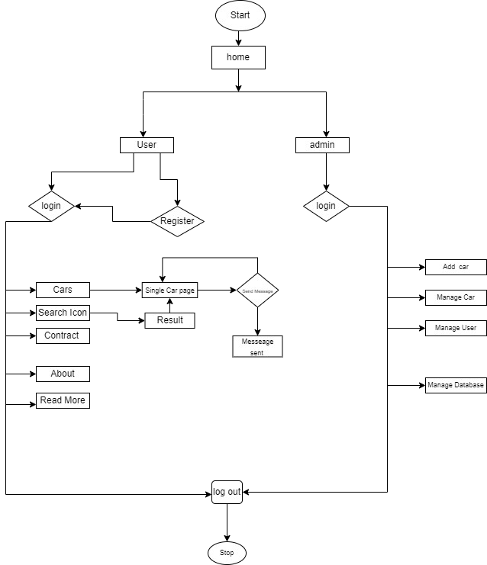

Figure 4.1: Flow chart of Car zone Web Portal

**4.4 Use Case Diagram**

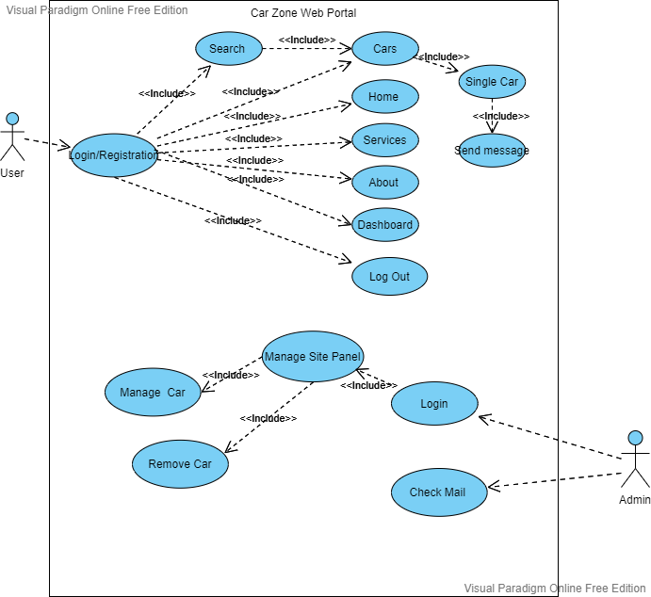

Figure 4.2: Use Case Diagram of Car zone Web Portal

**4.5 Class Diagram**

Car Zone Web Portal

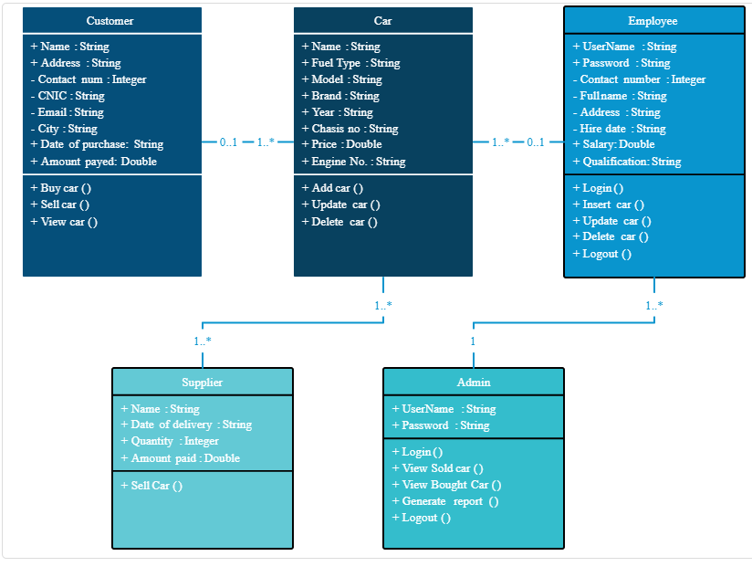

Figure 4.3: Class Diagram of Car zone Web Portal

**4.6 Conclusion**

All the figures are used to build our web application. It will help us to understand how work sequentially and how all the attributes will be connected with each other.

**Chapter 5**

**Implementation**

**5.1 Introduction**

As it is a web development project, so for proper purpose displaying and testing the project needs to be set up on a web server. For those reasons and live server hosting and setup is another problem for this type of big project.

**5.2 Requirements**

* Web Developer
* Software:

1. Notepad/Notepad++
2. Atom
3. Git
4. pgAdmin 4

* Personal Computer
* Internet
* Programming Language

1. HTML
2. CSS
3. Java Script
4. Python

**5.3 Implementation Tools**

* HTML
* CSS
* Java Script
* Bootstrap
* PostgreSQL
* Django Web Framework

5.3.1 What is PostgreSQL

PostgreSQL is an object-relational database management system (ORDBMS) based on POSTGRES, Version 4.2, developed at the University of California at Berkeley Computer Science Department. POSTGRES pioneered many concepts that only became available in some commercial database systems much later.

PostgreSQL is an open-source descendant of this original Berkeley code. It supports a large part of the SQL standard and offers many modern features:

* complex queries
* foreign keys
* triggers
* updatable views
* transactional integrity
* multi version concurrency control

Also, PostgreSQL can be extended by the user in many ways, for example by adding new

* data types
* functions
* operators
* aggregate functions
* index methods
* procedural languages

And because of the liberal license, PostgreSQL can be used, modified, and distributed by anyone free of charge for any purpose, be it private, commercial, or academic.

5.3.2 What is Django?

Django is a high-level Python web framework that enables rapid development of secure and maintainable websites. Built by experienced developers, Django takes care of much of the hassle of web development, so you can focus on writing your app without needing to reinvent the wheel. It is free and open source, has a thriving and active community, great documentation, and many options for free and paid-for support.

Django helps you write software that is:

* **Complete**: Django follows the "Batteries included" philosophy and provides almost everything developers might want to do "out of the box". Because everything you need is part of the one "product", it all works seamlessly together, follows consistent design principles, and has extensive and up-to-date documentation.
* **Versatile:** Django can be (and has been) used to build almost any type of website — from content management systems and wikis, through to social networks and news sites. It can work with any client-side framework, and can deliver content in almost any format (including HTML, RSS feeds, JSON, XML, etc).

Internally, while it provides choices for almost any functionality you might want (e.g. several popular databases, templating engines, etc.), it can also be extended to use other components if needed.

* **Secure**: Django helps developers avoid many common security mistakes by providing a framework that has been engineered to "do the right things" to protect the website automatically. For example, Django provides a secure way to manage user accounts and passwords, avoiding common mistakes like putting session information in cookies where it is vulnerable (instead cookies just contain a key, and the actual data is stored in the database) or directly storing passwords rather than a password hash.

A password hash is a fixed-length value created by sending the password through a cryptographic hash function. Django can check if an entered password is correct by running it through the hash function and comparing the output to the stored hash value. However due to the "one-way" nature of the function, even if a stored hash value is compromised it is hard for an attacker to work out the original password.

Django enables protection against many vulnerabilities by default, including SQL injection, cross-site scripting, cross-site request forgery and click jacking (see Website security for more details of such attacks).

* **Scalable:** Django uses a component-based "shared-nothing" architecture (each part of the architecture is independent of the others, and can hence be replaced or changed if needed). Having a clear separation between the different parts means that it can scale for increased traffic by adding hardware at any level: caching servers, database servers, or application servers. Some of the busiest sites have successfully scaled Django to meet their demands (e.g., Instagram and Disqus, to name just two).
* **Maintainable**: Django code is written using design principles and patterns that encourage the creation of maintainable and reusable code. In particular, it makes use of the Don't Repeat Yourself (DRY) principle so there is no unnecessary duplication, reducing the amount of code. Django also promotes the grouping of related functionality into reusable "applications" and, at a lower level, groups related code into modules (along the lines of the Model View Controller (MVC) pattern).
* **Portable:** Django is written in Python, which runs on many platforms. That means that you are not tied to any particular server platform, and can run your applications on many flavors of Linux, Windows, and Mac OS X. Furthermore, Django is well-supported by many web hosting providers, who often provide specific infrastructure and documentation for hosting Django sites.

5.3.3 What does Django code look like?

In a traditional data-driven website, a web application waits for HTTP requests from the web browser (or another client). When a request is received the application works out what is needed based on the URL and possibly information in POST data or GET data. Depending on what is required it may then read or write information from a database or perform other tasks required to satisfy the request. The application will then return a response to the web browser, often dynamically creating an HTML page for the browser to display by inserting the retrieved data into placeholders in an HTML template.

Django web applications typically group the code that handles each of these steps into separate files:

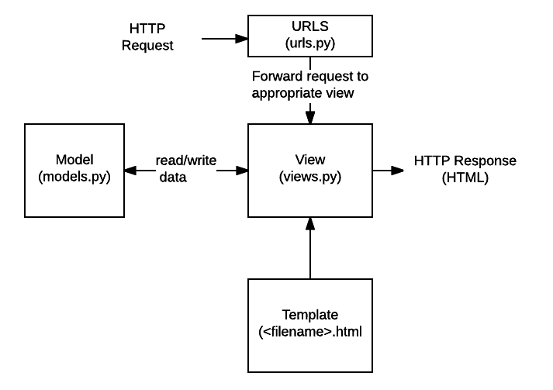

Figure 5.1: How Django Web Framework works

5.3.4 Database tables

The database system helps car-portal sites identify potential customers based on the aggregated information. Sales teams can use customer data stored on a website to create targeted lists that will be used to guide marketing efforts.

Key Features are:

* Provider structure
* Track data
* Customer information

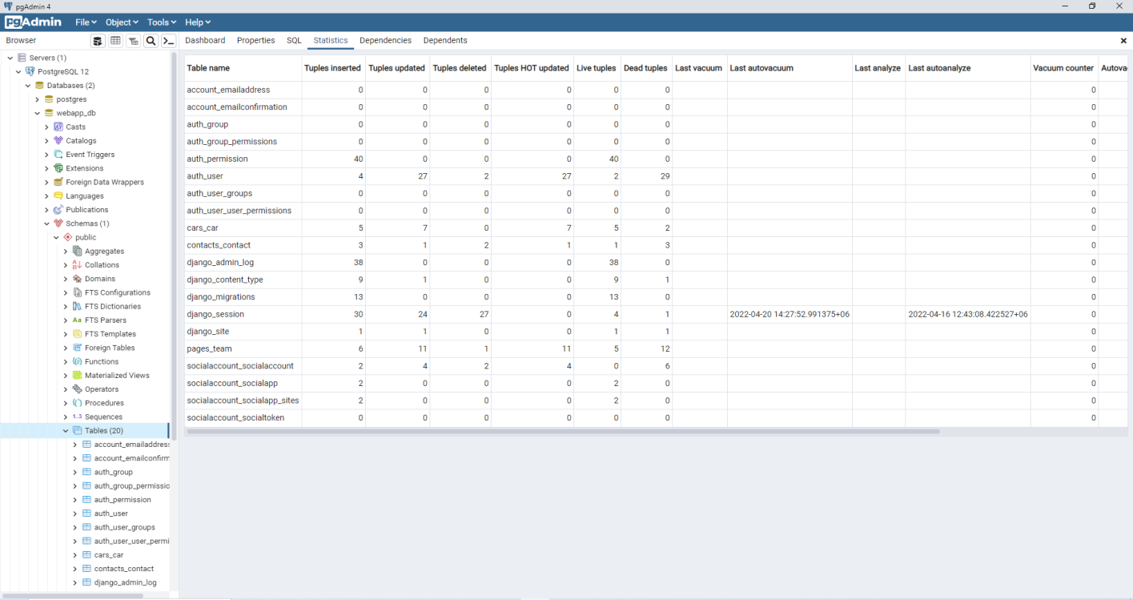

Figure 5.2: Database

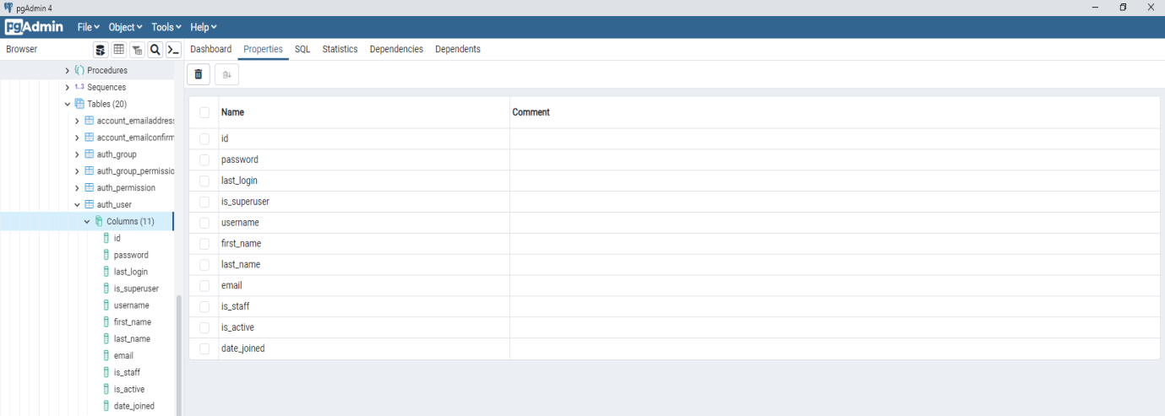

Figure 5.3: Columns of auth_user table.

5.3.5 Login Module & Other Modules

The login module is important for admin access to management of an admin of the website which includes the user, cars, adding car, change user's password, etc.

It reads metadata from your models to provide a quick, model-centric interface where trusted users can manage content on your site. The admin’s recommended use is limited to an organization’s internal management tool. It’s not intended for building your entire front end around.

The admin has many hooks for customization, but beware of trying to use those hooks exclusively. If you need to provide a more process-centric interface that abstracts away the implementation details of database tables and fields, then it’s probably time to write your own views.

Admin login

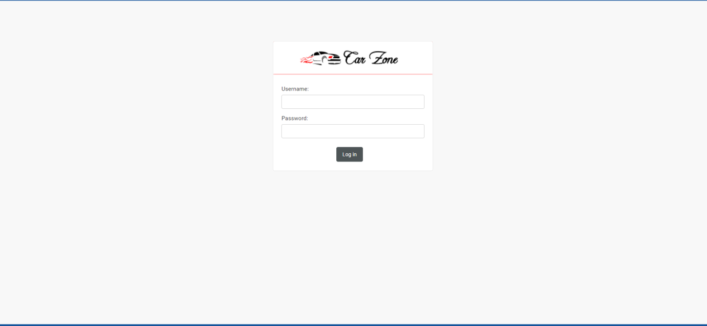

Figure 5.4: Admin login

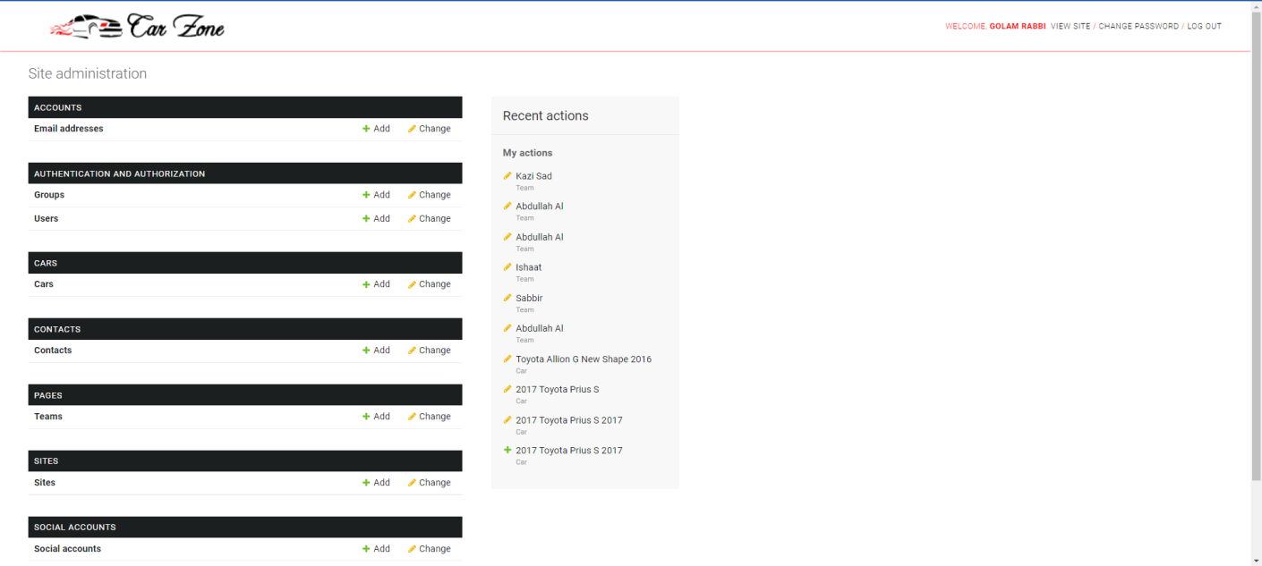

Figure 5.5: Site Administration

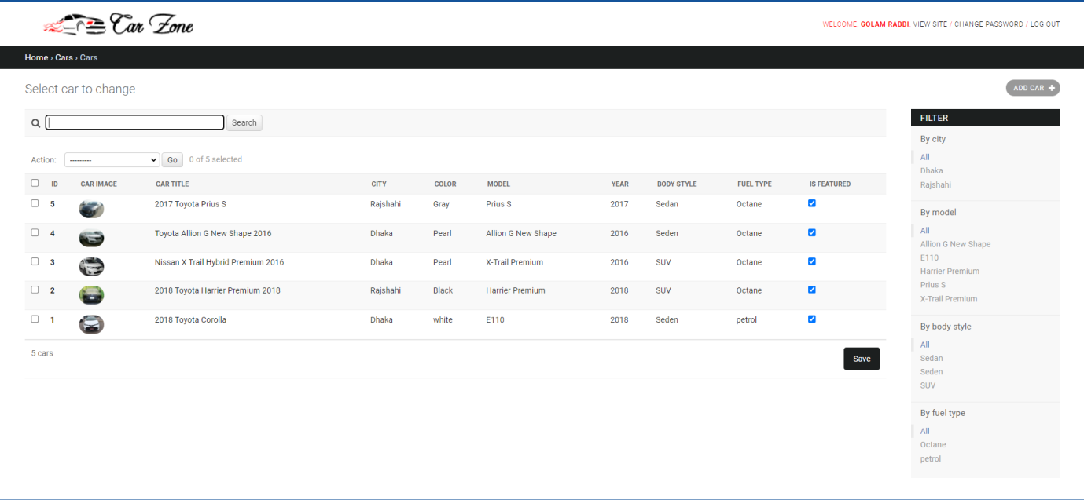

Figure 5.6: Cars Panel

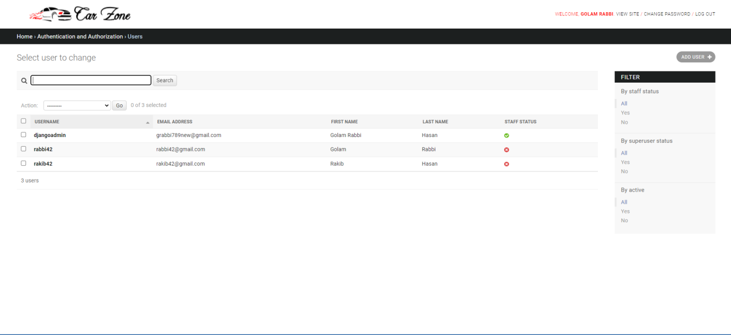

Figure 5.7: User Details in admin panel

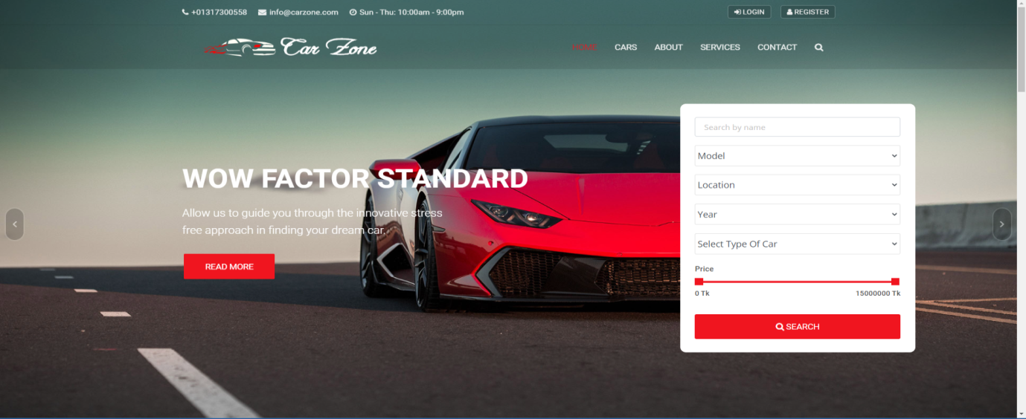

Figure 5.8: Homepage of Car Zone Web Portal

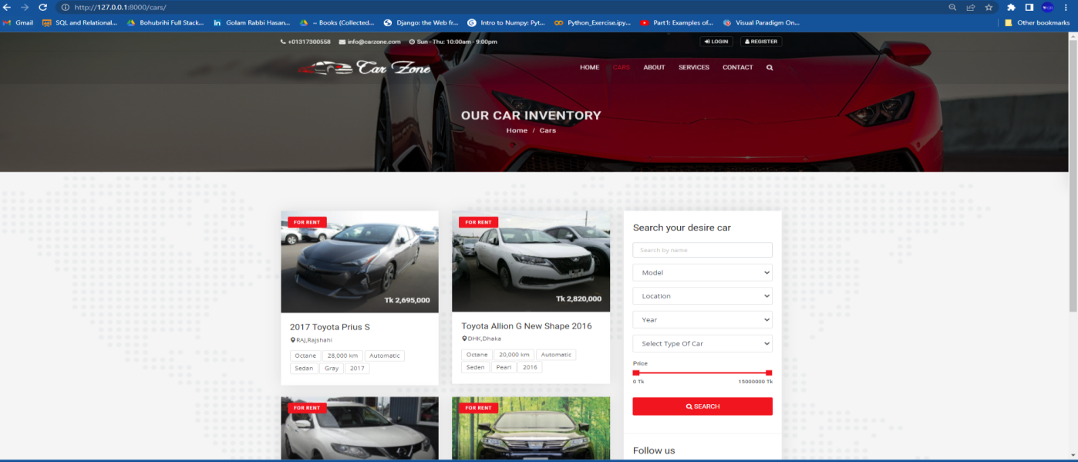

Figure 5.9: Car Inventory Page of Car Zone Web Portal

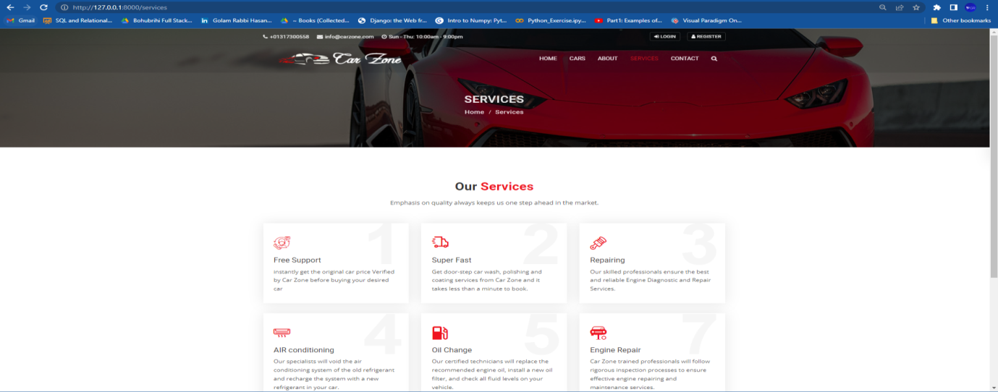

Figure 5.10: Services Page of Car Zone Web Portal

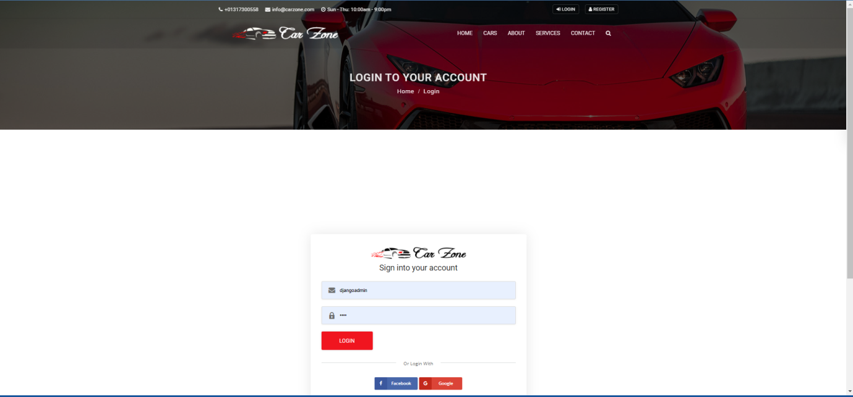

Figure 5.11: Login Page of Car Zone Web Portal

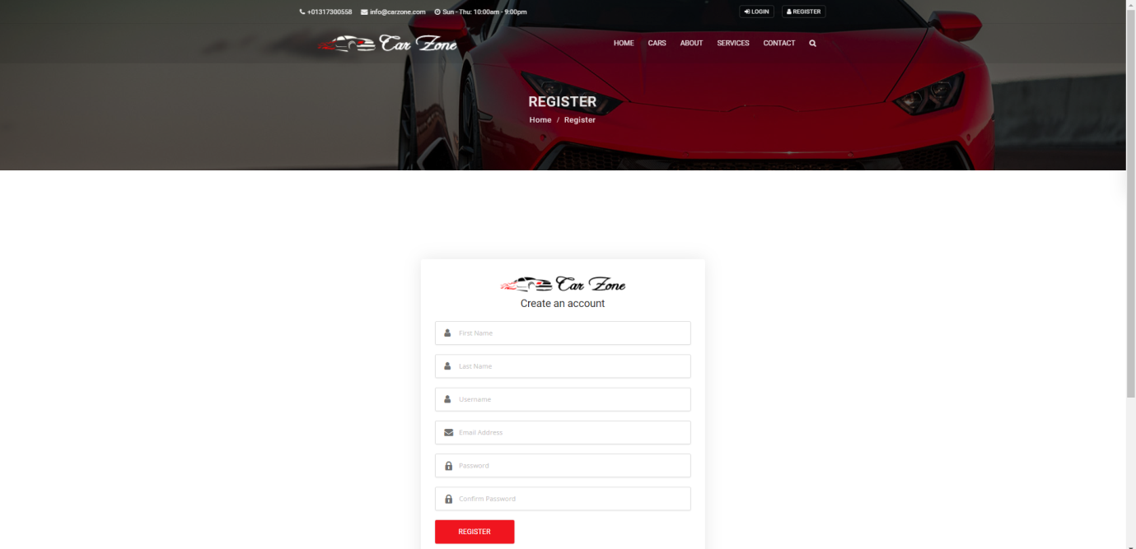

Figure 5.12: Register Page of Car Zone Web Portal

**5.4 Conclusion**

Most often, changes are identified by looking at performance and quality control data. Routine performance and quality control measurements should be evaluated on a regular basis throughout the implementation phase. Gathering reports on those measurements will help us determine where the problem is and recommend changes to fix it.

**Chapter 6**

**TESTING AND INTEGRATION**

**6.1 Introduction**

Test Report is a document which contains a summary of all test activities and final test results of a testing project. Test report is an assessment of how well the Testing is performed. Based on the test report, stakeholders can evaluate the quality of the tested product and make a decision on the software release. Our web application is tested by using RAD model. The Rapid Application Development (or RAD) model is based on prototyping and iterative model with no (or less) specific planning. In general, RAD approach to software development means putting lesser emphasis on planning tasks and more emphasis on development and coming up with a prototype. Some initial requirements and architecture envisioning need to be done. It is better for software products that have their feature sets redefined during development because of user feedback and other factors.

**6.2 Types of testing**

* **Unit testing:**Unit testing involves the design of test cases that validate that the internal program logic is functioning properly, and that program inputs produce valid outputs. All decision branches and internal code flow should be validated. It is the testing of individual software units of the application .it is done after the completion of an individual unit before integration. This is a structural testing, that relies on knowledge of its construction and is invasive. Unit tests perform basic tests at component level and test a specific business process, application, and/or system configuration. Unit tests ensure that each unique path of a business process performs accurately to the documented specifications and contains clearly defined inputs and expected results.
* **Integration testing:** Integration tests are designed to test integrated software components to determine if they actually run as one program. Testing is event driven and is more concerned with the basic outcome of screens or fields. Integration tests demonstrate that although the components were individually satisfaction, as shown by successfully unit testing, the combination of components is correct and consistent. Integration testing is specifically aimed at exposing the problems that arise from the combination of components.
* **System Test:** System testing ensures that the entire integrated software system meets requirements. It tests a configuration to ensure known and predictable results. An example of system testing is the configuration-oriented system integration test. System testing is based on process descriptions and flows, emphasizing pre-driven process links and integration points.
* **Test Results:** All the test cases mentioned above passed successfully. No defects encountered.
* **Acceptance Testing:** User Acceptance Testing is a critical phase of any project and requires significant participation by the end user. It also ensures that the system meets the functional requirements.

**6.3 Conclusion**

All the part of the web application is tested and the result is good. There were some bugs in some part of the application. We fixed that and complete the project as required.

**Chapter 7**

**MAINTENANCE**

**7.1 Introduction**

Maintenance plays an important role in an effective mine. Through short daily inspections, cleaning, lubricating, and making minor adjustments, small problems can be detected and corrected before they become a major problem that can stop production. Maintenance should keep systems functioning so a company’s goals can be achieved. This includes meeting the requirements of CRAMP parameters (Cost, Reliability, Availability, Maintainability, and Productivity) for any automated systems.

## 7.2 What Is Website Maintenance?

Website maintenance is the act of regularly checking your website for issues and mistakes and keeping it updated and relevant. This should be done on a consistent basis in order to keep your website healthy, encourage continued traffic growth, and strengthen your SEO and Google rankings. Keeping a website well maintained and attractive is important to companies big and small in order to engage and retain customers. It’s easy for businesses, especially startups, to cut corners and let a few tasks slide. Website maintenance can easily become one of those things as it doesn’t always present immediate issues. However, just like your health can fall apart if you go too long without a regular checkup, so can the health of your website.

Regular monitoring of your website is a must for keeping your business running smoothly.

**7.3 Methods of Maintenance**

Our system will provide the following benefits if we follow the maintenance method: -

**1. Scan for Vulnerabilities**

Security should be the primary reason for website maintenance. Check for the spam that may have surpassed your filters. Scanning for vulnerabilities regularly assures that your website is not attacked or taken over.

**2. Repairs and Fixes**

This is all related to errors, bugs, and broken links. Both internal and external links should be checked. A link checker can be run to look for broken links that frustrate the users and reduce the search engine rankings.

**3. Browser Compatibility Testing**

Ensure that all aspects of your website are functioning properly in the most common browsers. Your website must also be compatible with less-used browsers.

**4. Software Update**

The critical software your site relies on should be updated. For example; the content management system, its themes, and plugins. Also, upgrade non-critical software if they are worth applying.

**5. Website Backups**

The database backups would be automatically performed on a weekly basis and restored at least once every six months

**6. Site Speed**

This is a very critical point to check. Use Yahoo’s YSlow or Google Page speed Insights to identify the issues which are slowing your site’s speed.

**7.4 Conclusion**

Figure 03: Use case Diagram of Web store management System

Figure 03: Use case Diagram of Web store management System

A holistic approach works best, one able to integrate the evaluations, not only of the systems themselves, but also of their interactions with each other and their environment. So, maintenance phase is important for every web application.

**Chapter 8**

**CONCLUSION**

**8.1 Introduction**

Car buying & selling business has emerged with a new goody compared to the past experience where every activity concerning car buy and sell business is limited to a physical location only. Even though the physical location has not been totally eradicated; the nature of functions and how these functions are achieved has been reshaped by the power of internet.  
Nowadays, customers can reserve cars online, inquiry about car online, and have the car brought to their door step once the customer is a registered member or go to the office to pick the car. The web based car buy and sell system has offered an advantage to both customers as well as Car Dealership Company to efficiently and effectively manage the business and satisfies customers’ need at the click of a button.

This project helps me to do better understand the development process of modern dynamic web applications and the technologies used to implement them. The design of the project includes a data model and process with real-life examples. The building of the project has given me precise knowledge about the latest technology like "Django Web Framework" to develop an Car trading web application and better knowledge of the business industry.

**8.2 Future Work**

Figure 03: Use case Diagram of Web store management System

Figure 03: Use case Diagram of Web store management System

### AI Driven Chat

* We intend to add a payment getaway structure in the future.
* We would like to implement a regular backup mechanism to back up the

employee database to avoid disasters.

* The system can be developed in such a way that its existing features can

be modified to better versions.

* Renting a car’ Button

**8.3 Features**

* Easy to use.
* It is completely secure.
* It is controlled by admin.
* This system is easily compatible with most of the web browsers.
* It is very interactive and saves time.
* Admin can view all the records whenever necessary with ease.
* Login using social account
* Free of cost registration in the website
* Commission is not required in buying/selling used cars

**8.4 Conclusion**

This project was created with the intention of being utilized for Car sellers and the administrator. It is designed for usage in small businesses with a modest number of employees. The administrator can add, manipulate, and update information based on the request and purge his users' whole car database. The administrator has the ability to create new section and new car class. And get rid of them. Users can also be assigned to specified roles by the administrator. The needed records are freely accessible to the administrator at any time instantly. There are numerous confirmations. If implemented, the administrator would be able to enter accurate data. This project's major goal is to reduce the hassle for some backdated companies. The purpose of a framework is to save time.

**REFERENCE**

|  |  |
| --- | --- |
| [1] | Ghimire, Devndra. "Comparative study on Python web frameworks: Flask and Django." (2020). |
| [2] | Ambre, A., Gaikwad, P., Pawar, K., & Patil, V. (2019). Web and android application for comparison of e-commerce products. *no*, *4*, page 266-268. |
| [3] | Andersen Virginia, Access 2000: The Complete Reference, Blacklick, OH, USA: McGraw-Hill Professional Book Group, 2001, Available at: http://site.ebrary.com/lib/vaxjo/Doc?id=5002842 (2006-05-25). |
| [4] | Brown, Ryan. "Django vs flask vs pyramid: Choosing a python web framework." *Recuperado el* 31 (2015). |
| [5] | Farrell, Doug. “Data Management with Python, SQLite, and SQLAlchemy –realpython.com” *realpython.com,2012*. [online]  Available at: https://realpython.com/python-sqlite-sqlalchemy |

22